CO4-AT1-CODING CHALLENGE
DESIGN AND ANALYSIS OF ALGORITHMS (DAA)
NAME: S. ALEX MADDY
REG: 192565060

TITLE
Floyd-Warshall Algorithm
A communication network consists of multiple nodes where not all nodes are directly connected. The system needs to compute the shortest path between every pair of nodes to optimize routing. Using the Floyd-Warshall algorithm, update the distance matrix to reflect the shortest possible paths between all node pairs.
Sample Input:
n = 3
Graph =
0 5 INF
2 0 3
INF INF 0
Expected Output:
0 5 8
2 0 3
INF INF 0

1. Aim:
To implement the Floyd–Warshall Algorithm in Python to find the shortest paths between every pair of vertices in a weighted graph by systematically updating the distance matrix using a dynamic programming approach.
2. Objectives
- To understand the concept of all-pairs shortest paths.
- To implement the Floyd–Warshall algorithm using a distance matrix.
- To represent unreachable vertices using INF (infinity).
- To update the shortest distance between every pair of vertices.
- To understand the dynamic programming principle used in Floyd–Warshall.
- To analyze the time and space complexity of the algorithm.
- To verify the algorithm using the given sample graph.
- To understand how the algorithm can be applied to communication and routing networks.

3. Problem Statement
- A communication network consists of multiple nodes connected through weighted links, where the weights represent distance, cost, or communication time.
- Some nodes may not have direct connections, so communication may require passing through intermediate nodes.
- The objective is to find the shortest path between every pair of nodes in the network.
- The network is represented using a distance matrix, where INF indicates that no direct connection exists.
- The Floyd–Warshall Algorithm is used to solve this all-pairs shortest path problem by considering each node as an intermediate vertex.
- For every pair of nodes, the algorithm checks whether travelling through an intermediate node provides a shorter path and updates the distance matrix accordingly.
- The final matrix contains the minimum possible distance between all pairs of nodes, helping optimize communication and routing in the network

4. Algorithm
- Start with the given adjacency/distance matrix.
- Replace every unreachable edge with INF.
- Set the distance from every vertex to itself as 0.
- Select each vertex one by one as an intermediate vertex k.
- For every source vertex i, check every destination vertex j.
- Calculate the distance through the intermediate vertex:
dist[i][k] + dist[k][j]
- Compare it with the current distance:
dist[i][j]
- If the new path is shorter, update dist[i][j].
- Repeat the process for all intermediate vertices.
10.Print the final distance matrix.
5. PSEUDO CODE:
FloydWarshall(graph, n)
dist ← graph
for k ← 0 to n-1
for i ← 0 to n-1
for j ← 0 to n-1

if dist[i][k] != INF AND dist[k][j] != INF
new_distance ← dist[i][k] + dist[k][j]
if new_distance < dist[i][j]
dist[i][j] ← new_distance
return dist

6. PYTHON CODE:
INF = float('inf')
def print_matrix(matrix):
"""
Function to display the distance matrix in a readable format.
"""
for row in matrix:
for value in row:
if value == INF:
print("INF", end="\t")
else:
print(value, end="\t")
print()
def floyd_warshall(graph):
# Number of vertices
n = len(graph)
# Create a copy of the original graph
# so that the original matrix is not modified.
dist = [row[:] for row in graph]
# Consider every vertex as an intermediate vertex
for k in range(n):
# Select source vertex
for i in range(n):
# Select destination vertex
for j in range(n):
# Check whether both parts of the path exist
if dist[i][k] != INF and dist[k][j] != INF:
# Distance through intermediate vertex k
new_distance = dist[i][k] + dist[k][j]
# Update if the new path is shorter
if new_distance < dist[i][j]:
dist[i][j] = new_distance
return dist
# Number of vertices
n = 3
graph = [
[0, 5, INF],
[2, 0, 3],
[INF, INF, 0]
]
print("Original Distance Matrix:")
print("--------------------------------")
print_matrix(graph)
# Apply Floyd-Warshall algorithm
shortest_paths = floyd_warshall(graph)
print("\nShortest Distance Matrix:")
print("--------------------------------")
print_matrix(shortest_paths)
7. OUTPUT:
- This function implements the Floyd–Warshall algorithm to calculate the shortest paths between every pair of vertices in a weighted graph.

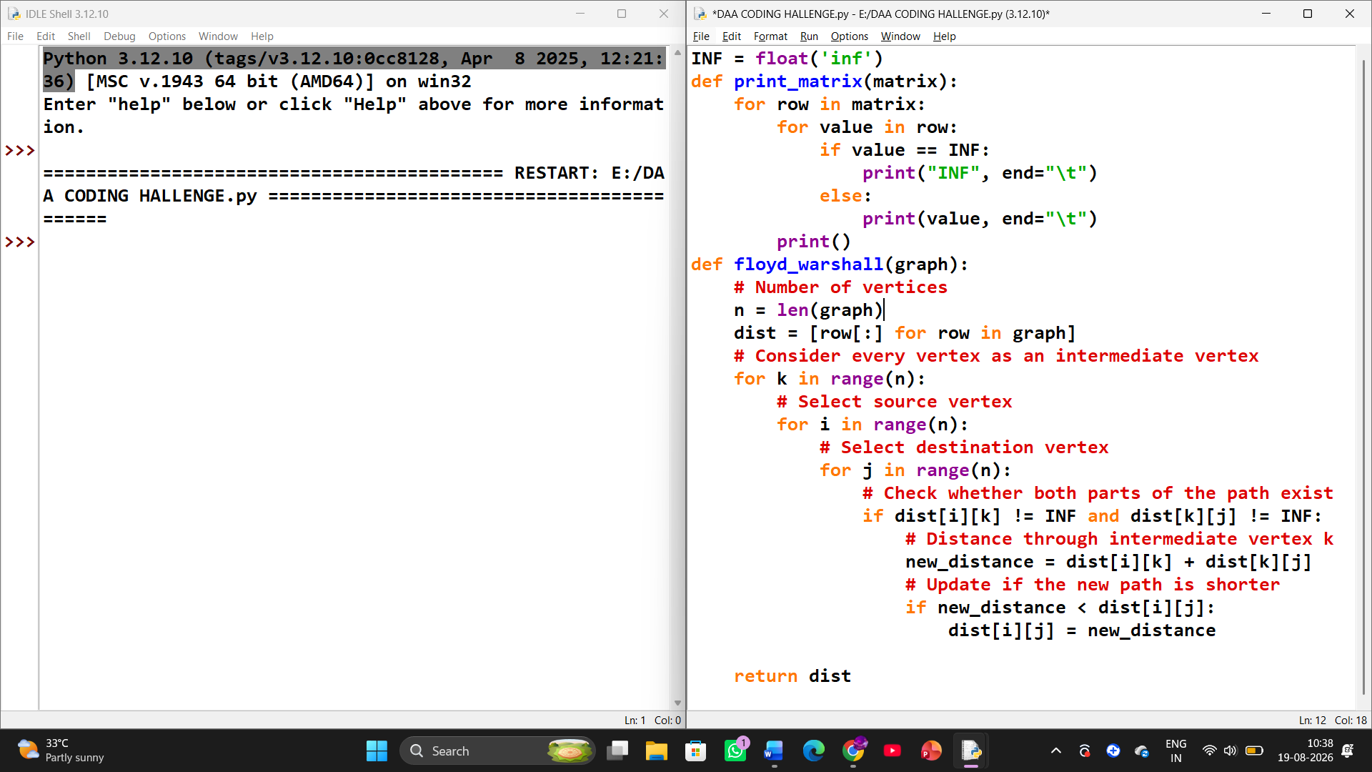

Step 1 — Initial Graph
The algorithm starts with the given graph and creates the initial distance matrix. INF represents that there is no direct path between two vertices.
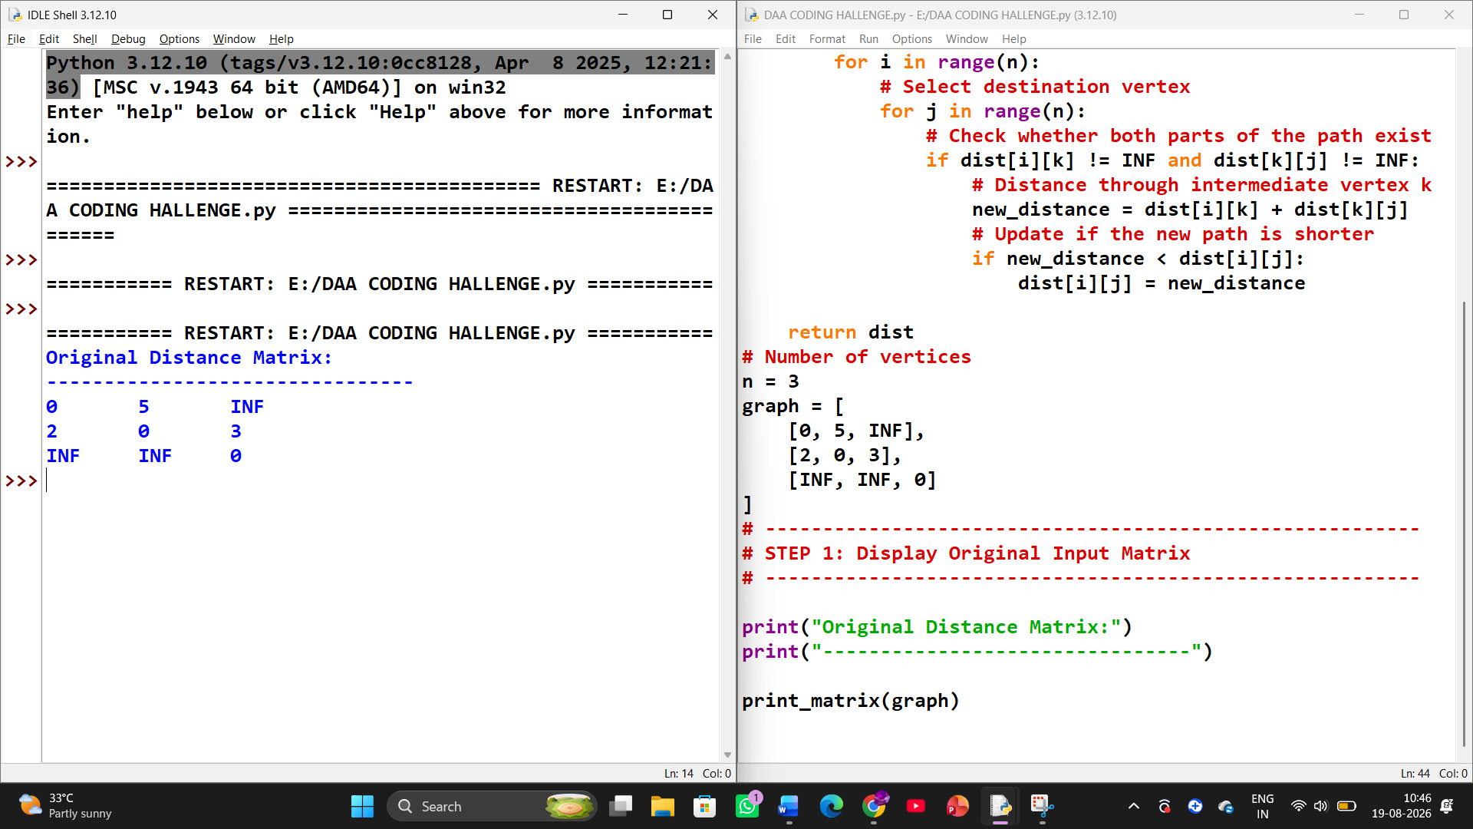
Step 2 — Vertex 0 as Intermediate
Vertex 0 is considered as an intermediate vertex. No shorter paths are found, so the distance matrix remains unchanged.
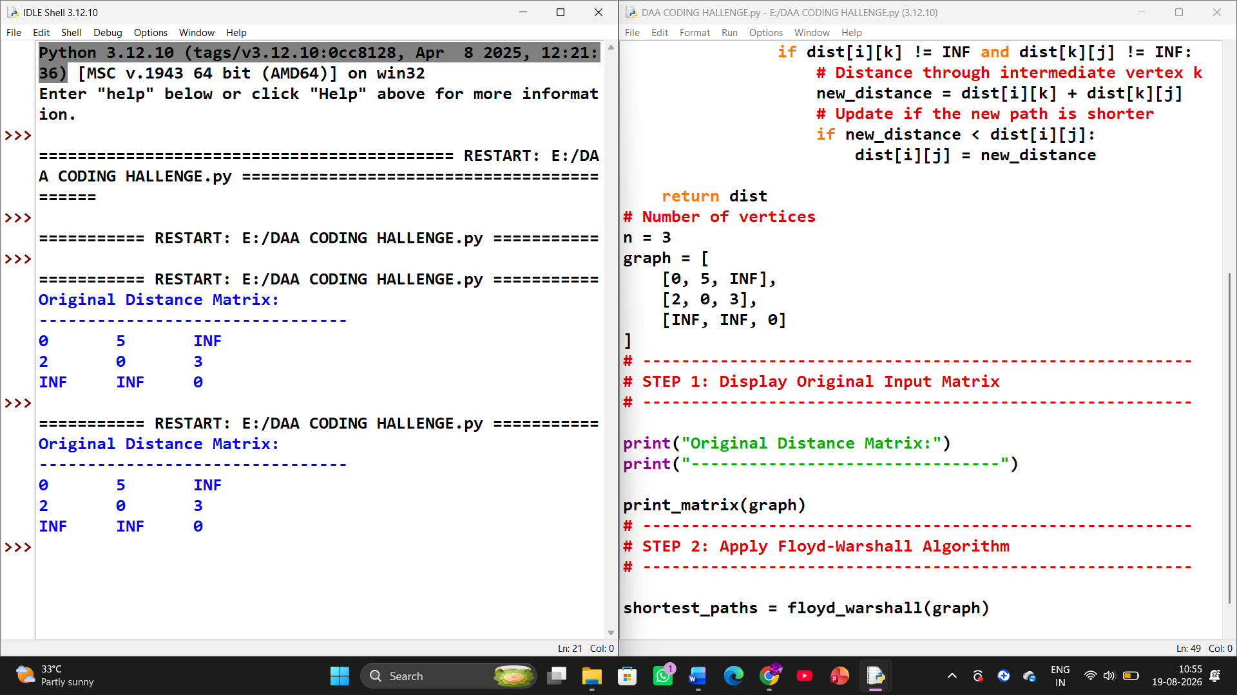

Step 3 — Vertex 1 as Intermediate
Vertex 1 is considered as an intermediate vertex. A shorter path is found from 0 → 2 through 1:
0 → 1 → 2 = 5 + 3 = 8
Therefore, INF is replaced by 8.
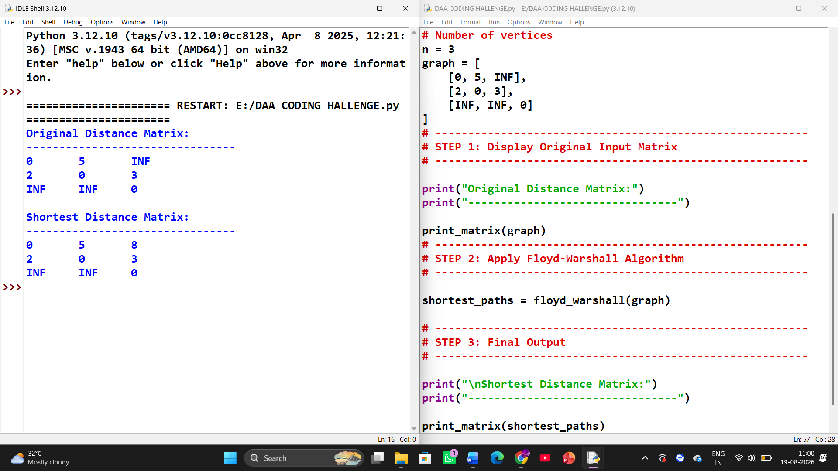
8. Time Complexity
There are three nested loops:
for k in range(n):
for i in range(n):
for j in range(n):
Each loop can execute approximately n times.
Therefore:
Time Complexity = O(n³)
9. Conclusion
The Floyd–Warshall algorithm efficiently determines the shortest paths between every pair of vertices in a weighted graph. It repeatedly considers each vertex as an intermediate point and updates the distance matrix whenever a shorter path is discovered.
For the given graph, the initial path from vertex 0 to vertex 2 is unavailable directly. However, by passing through vertex 1, the algorithm discovers:
0 → 1 → 2
with total cost:
5 + 3 = 8
Hence, the final shortest-path matrix is:
0 5 8
2 0 3
INF INF 0
This demonstrates how Floyd–Warshall can be used to optimize routing in a communication network by determining the shortest possible paths between all connected pairs of nodes.

